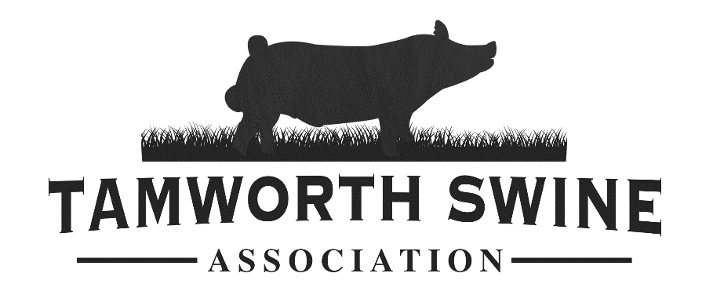
2021 National Tamworth Swine Show
August 28th-29th
Tipton County Fairgrounds
1200 S Main St Tipton, IN 46072
(In conjunction with the National Hereford Show)
Judge: TBD  Health Requirements: All pigs must have health papers and 840 Tag.  Entry Information  $35/head for open show  $30/head for junior show  $5 for showmanship  Entries made payable to:  Tamworth Swine Association  53147 Rosewood Rd  New Carlisle, IN 46552  Postmarked by August 15th or could be subject to late entry fee.  No prospect or weanling pig classes.  If you would like to donate to the fun auction, bring the items during check-in. | Schedule  Friday August 27th  Junior and Open show  Check-in 5:00pm-8:00pm EST  Saturday August 28th  Junior Show Check-in 6:00am-8:00am EST  Open Show Check-in 6:00am-11:00am EST  Junior Show begins at 9:00am EST  Tamworth Annual Meeting 5:00pm EST  Sunday August 29th  Open Show begins at 9:00am EST  Tamworth Boars, Tamworth Gilts, Tamworth Bred Gilts. Followed by National Hereford Show. Sale will start 1 hour after the conclusion of the open show. Fun Auction, Scholarship gilt, then breeds will be mixed for the sale.

Show and Sale Questions:
Tom Shanafelt 317-345-2153 Kelley Bradshaw 574-222-0073
secretary@tamworthswine.org

